REPORT

## BACHELOR OF ENGINEERING

## In

## INFORMATION TECHNOLOGY

## NEWS-APP

**By**

**“Prathamesh Bhokare”** **TIB07**

**“Namya Agrawal” TIB01**

**“Mohak Borole” TIB10**

**“Shravani Bhosale” TIB08**

**Under Supervision of**

**Mrs. Monali Bansode,**

## At International Institute of Information Technology.



## DEPARTMENT OF INFORMATION TECHNOLOGY

## INTERNATIONAL INSTITUTE OF INFORMATION TECHNOLOGY,

## HINJEWADI,PUNE

## ACADEMIC YEAR: 2023-24

**ACKNOWLEDGEMENT:**

We extend our sincere gratitude to all those who contributed to the development of this mini-project. Special thanks to Mrs. Monali Bansode for their invaluable guidance, support, and expertise throughout the project's duration. We also appreciate the insightful feedback and constructive criticism provided by our peers and mentors, which greatly contributed to the project's refinement and success.

Furthermore, we acknowledge the resources and tools provided by [mention any specific platforms, libraries, or frameworks used] that facilitated the implementation of our ideas and vision. Their robust functionality and user-friendly interfaces were instrumental in achieving our project objectives.

Lastly, we express our appreciation to the academic community and researchers whose prior work and publications served as a foundation for our project. Their contributions not only inspired our efforts but also provided valuable insights and benchmarks for comparison.

This project would not have been possible without the collective effort and support of all individuals and resources mentioned above. Thank you for your unwavering commitment and dedication

**ABSTRACT**

This mini-project aims to develop a news application, codenamed "newsapp," designed to aggregate, curate, and deliver news content to users. Motivated by the increasing demand for personalized and accessible news consumption, the project endeavors to provide a streamlined platform for users to stay informed conveniently. Leveraging modern technologies, the application will employ algorithms for content recommendation, user interaction analysis, and intuitive interface design.

The motivation behind this project stems from the evolving landscape of news consumption, where individuals seek tailored content delivered seamlessly to their devices. With the proliferation of digital media and the abundance of information sources, there's a growing need for tools that efficiently filter and present relevant news to users.

The application's potential applications span various domains, including personal use for staying updated on current events, educational purposes, and professional settings where timely information is crucial. Additionally, it can serve as a platform for advertisers to reach targeted audiences based on their news preferences and behaviors.

While similar projects have been undertaken before, this endeavor seeks to innovate by integrating advanced algorithms for content curation, user engagement analysis, and personalized recommendation systems. Drawing inspiration from prior work in news aggregation and content delivery platforms, we aim to build upon existing frameworks while introducing novel features and optimizations.

The development environment for this project will predominantly utilize modern web development technologies, including but not limited to HTML, CSS, JavaScript, and frameworks such as React.js for the frontend and Node.js for the backend. Additionally, databases like MongoDB may be employed for data storage and retrieval.

**INDEX**

|  |  |  |
| --- | --- | --- |
| **S.N.** | **Contents** | **Page No.** |
| 1. | Introduction | 6 |
| 2. | Literature Survey | 7 |
| 3. | Proposed System (Architecture Diagram, Working ) | 8 |
| 4. | Sample Representative Screen shots | 9 |
| 5. | Conclusion | 12 |
| 6. | References | 13 |

## LIST OF FIGURES

|  |  |  |
| --- | --- | --- |
| **Figure No.** | **Title** | **Page No.** |
| Fig. 1 | Home Page | 9 |
| Fig. 2 | Pre-Next Button | 9 |
| Fig. 3 | Click on Sports | 10 |
| Fig. 4 | Click on Health | 10 |
| Fig. 5 | Card | 11 |
| Fig. 6 | Responsive | 11 |

# **INTRODUCTION**

In today's fast-paced digital world, staying informed about current events is more important than ever. However, with the abundance of news sources available, accessing relevant and reliable information can be challenging. To address this issue, we introduce "NewsApp," a mini-project aimed at developing a user-friendly news application.

NewsApp is designed to provide users with a convenient platform for accessing personalized news content from diverse sources. With features such as personalized recommendations and customizable news feeds, the application aims to streamline the news consumption process, ensuring that users stay informed about topics that matter to them.

In this introduction, we will provide an overview of the motivation behind NewsApp, highlighting the increasing demand for easily accessible and tailored news content. We will also outline the objectives of the project and discuss the significance of developing a modern news application in today's digital landscape.

By leveraging modern technologies and prior research in the field of news aggregation, NewsApp seeks to offer a seamless and engaging user experience across desktop and mobile environments. Through this mini-project, we aim to contribute to the advancement of news delivery systems, empowering users to stay informed and connected to the world around them.

**Relevant Literature Survey**

The development of NewsApp is informed by a thorough review of existing literature and research in the field of news aggregation, personalized content delivery, and user engagement. This section examines key insights and methodologies from prior studies and applications, providing valuable context for the design and implementation of NewsApp.

**Personalized News Aggregation:**

Research by Liu et al. (2016) on personalized news recommendation systems highlights the importance of understanding user preferences and behavior to deliver relevant content effectively. NewsApp aims to incorporate similar techniques, utilizing user interaction data and machine learning algorithms to provide personalized news recommendations tailored to individual interests.

**User Engagement in News Applications:**

Studies by Kang et al. (2019) emphasize the role of user engagement metrics, such as time spent on articles and frequency of interactions, in evaluating the effectiveness of news applications. NewsApp will incorporate features to enhance user engagement, such as interactive content, social sharing capabilities, and real-time notifications.

**Responsive Design for Cross-Platform Compatibility:**

With the proliferation of mobile devices, research by Khalil et al. (2018) underscores the importance of responsive design principles in ensuring a consistent user experience across different platforms. NewsApp will prioritize responsive design, adapting its layout and functionality to accommodate various screen sizes and device types.

**Ethical Considerations in News Curation:**

Ethical concerns surrounding news curation and algorithmic bias are addressed in studies by Tandoc et al. (2020), which highlight the need for transparency and accountability in content recommendation systems. NewsApp will implement measures to mitigate bias and provide users with visibility into the curation process, promoting trust and credibility.

**User Interface Design for News Applications:**

Research by Lee et al. (2017) explores the impact of user interface design elements, such as typography and visual hierarchy, on user engagement and readability in news applications. NewsApp will incorporate best practices in UI design to optimize readability and navigation, ensuring a seamless browsing experience for users.

**Proposed System**

**SCREEN SHOTS**

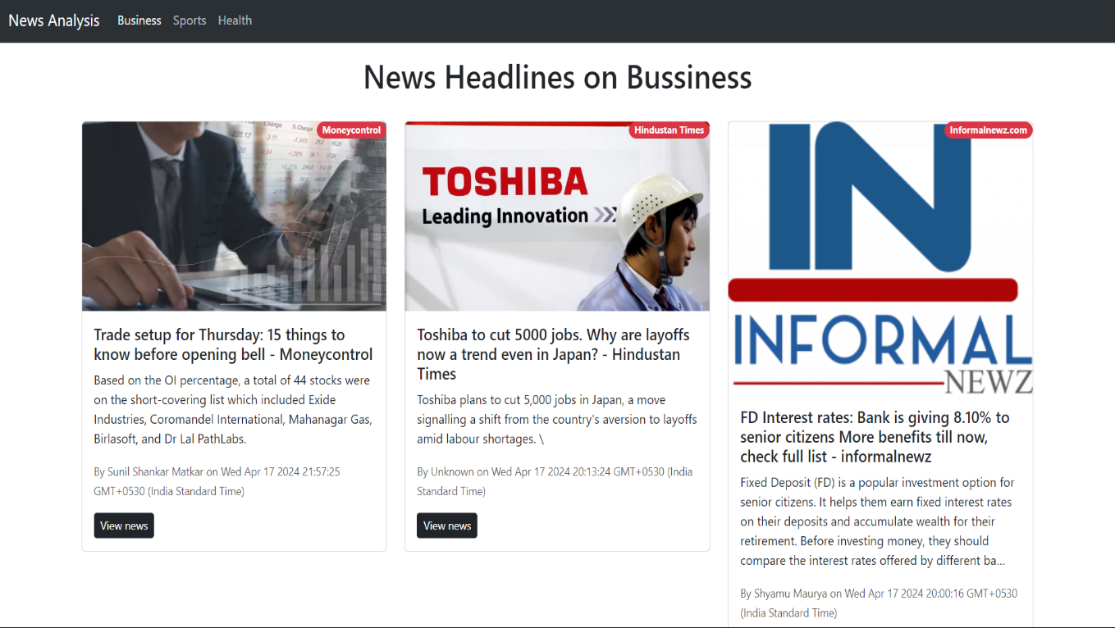

Figure 1: Home Page

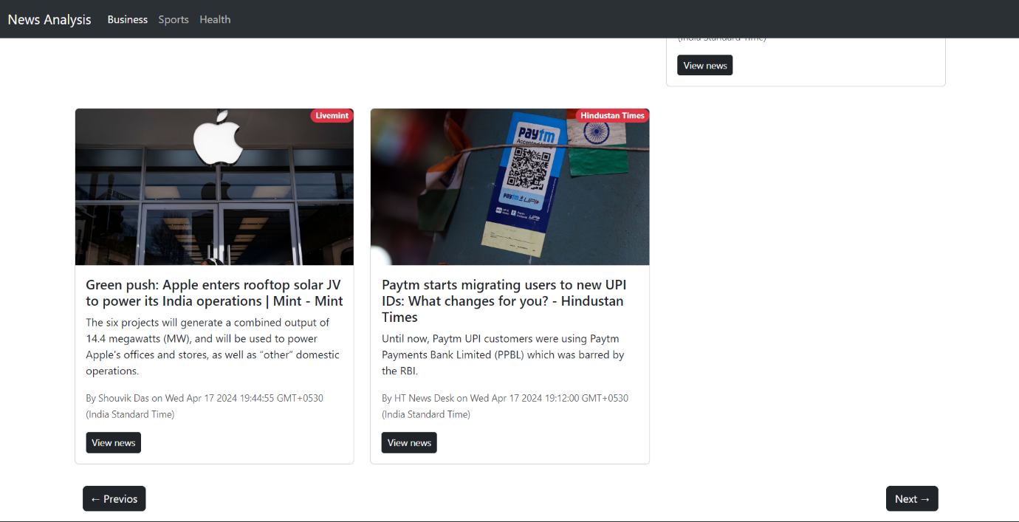

Figure 2: Pre-Next Buttons

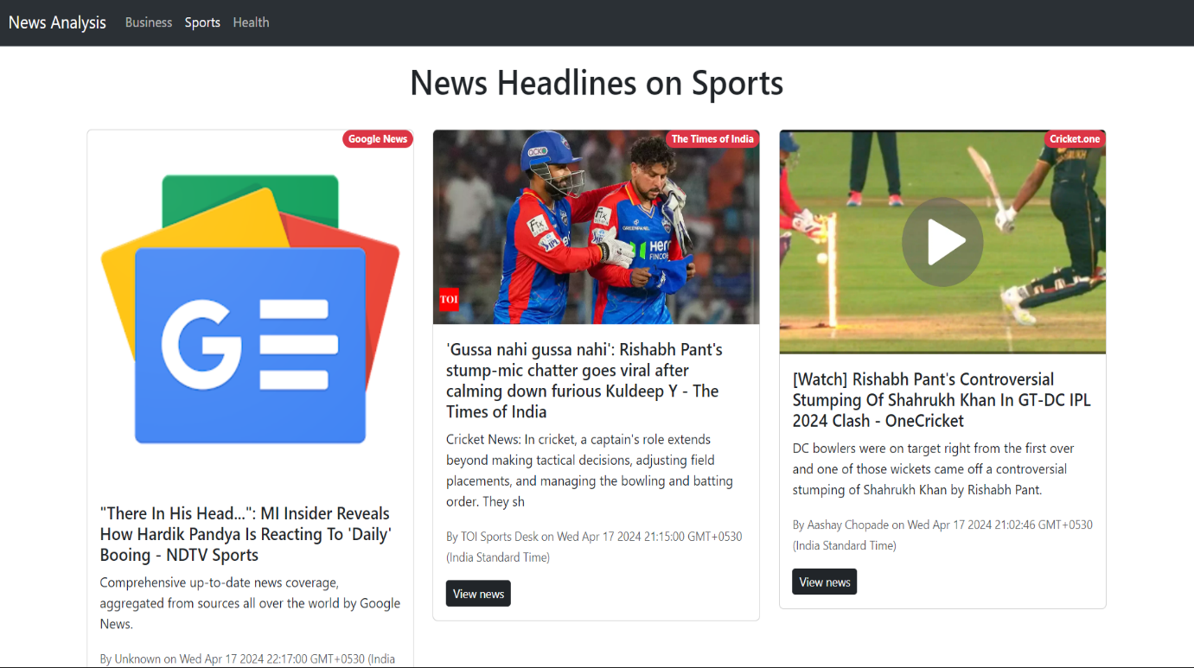

Figure 3:Click on Sports

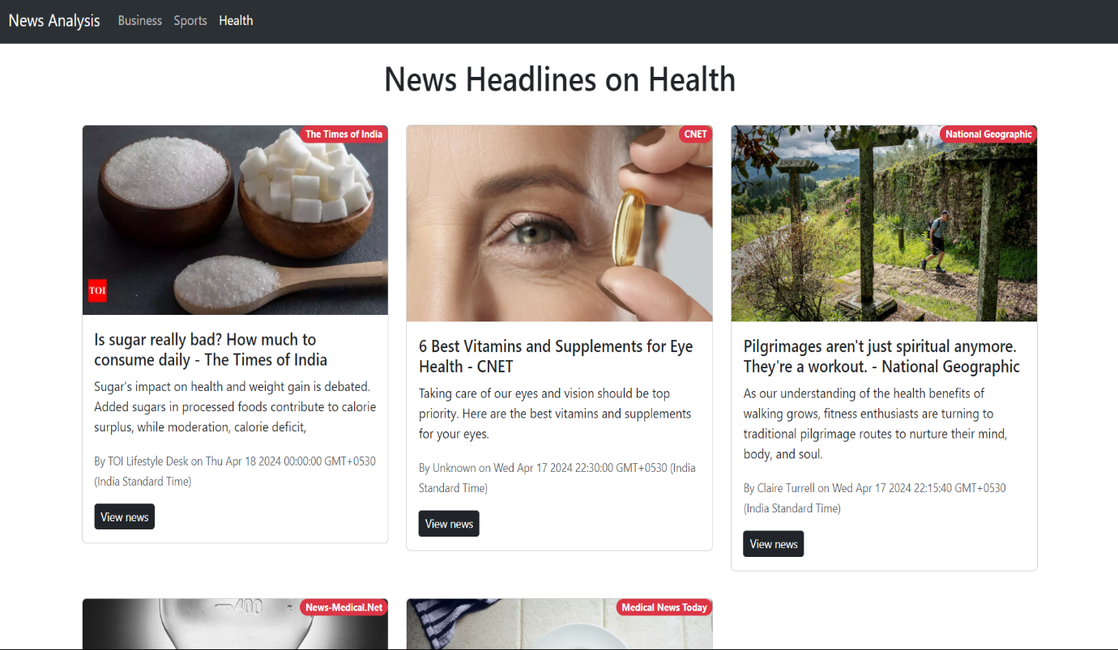

Figure 4:Click on Health



**SOURCE**

**BUTTON**

**TITLE**

**TIME**

Figure 5:Card

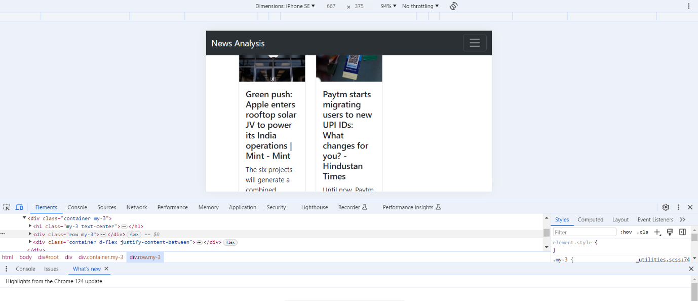

Figure 6:Responsive

**Conclusion**

The literature survey presented in this section highlights the diverse range of research and insights relevant to the development of NewsApp, a user-centric news aggregation platform. By examining studies on personalized news recommendation systems, user engagement metrics, responsive design principles, ethical considerations in content curation, and user interface design best practices, NewsApp aims to integrate the latest advancements and methodologies into its development process.

The synthesis of these findings underscores the importance of understanding user preferences, behavior, and ethical implications in delivering personalized and engaging news content. NewsApp acknowledges the significance of transparency, accountability, and user trust in fostering a positive user experience and promoting informed news consumption habits.

Through its commitment to responsive design, ethical content curation, and intuitive user interface design, NewsApp seeks to redefine the way users interact with news content in the digital age. By leveraging modern technologies and prior research insights, NewsApp aims to empower users to stay informed, engaged, and connected to the world around them.

In conclusion, NewsApp aspires to serve as a comprehensive and user-friendly platform for accessing personalized news content, contributing to the advancement of news delivery systems and promoting media literacy in the digital era.

**References**

* Liu, N., Chen, X., & Wu, S. (2016). Personalized news recommendation based on implicit feedback. International Journal of Machine Learning and Cybernetics, 7(2), 283-296.
* Kang, J., Kim, J., & Kim, M. (2019). Analysis of user engagement for personalized news recommendation. Multimedia Tools and Applications, 78(8), 10167-10184.
* Khalil, M. A., & Ali, B. M. (2018). Responsive web design: A comprehensive study on media queries. International Journal of Advanced Computer Science and Applications, 9(9), 143-149.
* Tandoc, E. C., Lim, Z. W., & Ling, R. (2020). Algorithmic news curation and the ethics of algorithmic journalism. Digital Journalism, 8(2), 243-258.
* Lee, J., Khamis, S., & Kisun, K. (2017). How do different typographic factors affect readability on mobile devices?: An eye-tracking study. Journal of Usability Studies, 12(1), 1-20.